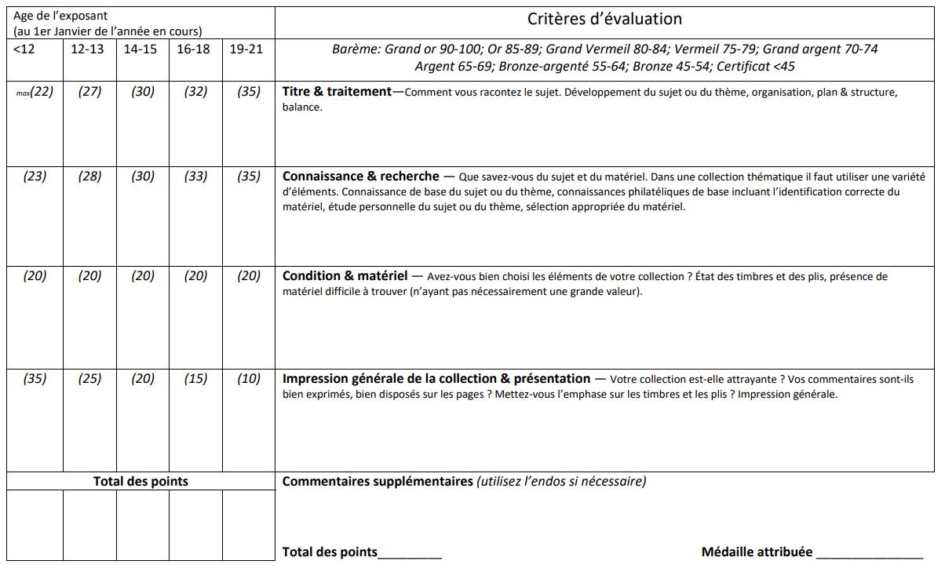

Titre___________________________________________________________________________________________________________ # ____________

Age______________ Juge répondant :_____________________________________________________ JUNIOR